

October 14, 2015

Guelph, ON – Congratulations to our Canadian members who represented Canada proudly at World Dairy Expo in Madison, Wisconsin. Canadian bred animals won four individual classes with the 1st place 5-Year-Old continuing on to win Senior and Grand Champion of the Brown Swiss show. Brown Heaven Glenn Fantasy, bred & owned by Ferme Brown Heaven, D Rousseau & J & G Charron, Quebec, has made history with the first Canadian bred and owned animal to win the Brown Swiss show at World Dairy Expo. What a huge accomplishment, congratulations! The Canadian winners were truly from right across Canada. Bradner Farms, Rob & Pat Donaldson & family from British Columbia had the 1st place Milking Yearling with Bradner Jongeleur Pastime. Troy McConnell from Nor Bella Acres Inc., Ontario, proudly led Nor Bella Paul Eve to the 1st prize position in the Junior 3-Year-Old class. No stranger to the show ring is Canadian bred Eloc Wagor Kandid, who took 1st place Aged Cow for breeder Dean Cole, Nova Scotia, and owner Elite Dairy, NY. Pictures of the winners are located on the back of this page.

Mark your calendar for the National show held at the Supreme Dairy Show in St. Hyacinthe, Quebec, on Thursday, November 5th. We encourage as many members as possible to participate at this show. If unable to exhibit animals, please take note of the date and plan to watch the show in support of our exhibitors.

Of Special Note …
As we continue to transition toward our new registrar at Holstein Canada for 2016, we ask members to submit any outstanding registrations or transfers to CLRC immediately. In order to make the move as smooth as possible and to limit the number of delays, we ask you to submit outstanding work at your earliest convenience. This will result in a herd book which is as current and accurate as possible. Detailed information will be provided later this year. If you have any questions or concerns please do not hesitate to contact the office.

The Brown Swiss breed has a new 95 point excellent cow. Congratulations to Gubelmann Brown Swiss Ltd. with Gubelman Special Danish, who joins the below elite, high point classified individuals.
NOR BELLA JETWAY PORTRAIT | EX | 96 | 3E | NOR BELLA ACRES INC. | ON
NOR BELLA BLEND SARAH | EX | 95 | 5E | NOR BELLA ACRES INC. | ON
NOR BELLA DOMINATE PETALS | EX | 95 | 4E | NOR BELLA ACRES INC. | ON
NOR BELLA SUPREME DABBLE | EX | 95 | 3E | NOR BELLA ACRES INC. | ON
RED BRAE LA ZEUS TATTI J | EX | 95 | 3E | BRADNER FARMS | BC
JA-KA HILLARY HILLBILLY | EX | 95 | 2E | BRADNER FARMS | BC
OLD MILL JP GRACE ET | EX | 95 | 2E | BRADNER FARMS | BC
EDENRIDGE WHITE CATHERINE | EX | 95 | 1E | DEAN & LEON BENDER | ON
GUBELMAN SPECIAL DANISH | EX | 95 | 1E | GUBELMANN BROWN SWISS LTD. | ON
RED BRAE LA SANDY ET | EX | 95 | 1E | DEAN & LEON BENDER | ON
TERRA NOVA SARAJEVO | EX | 95 | 1E | AGRO PECURIA AMERICA

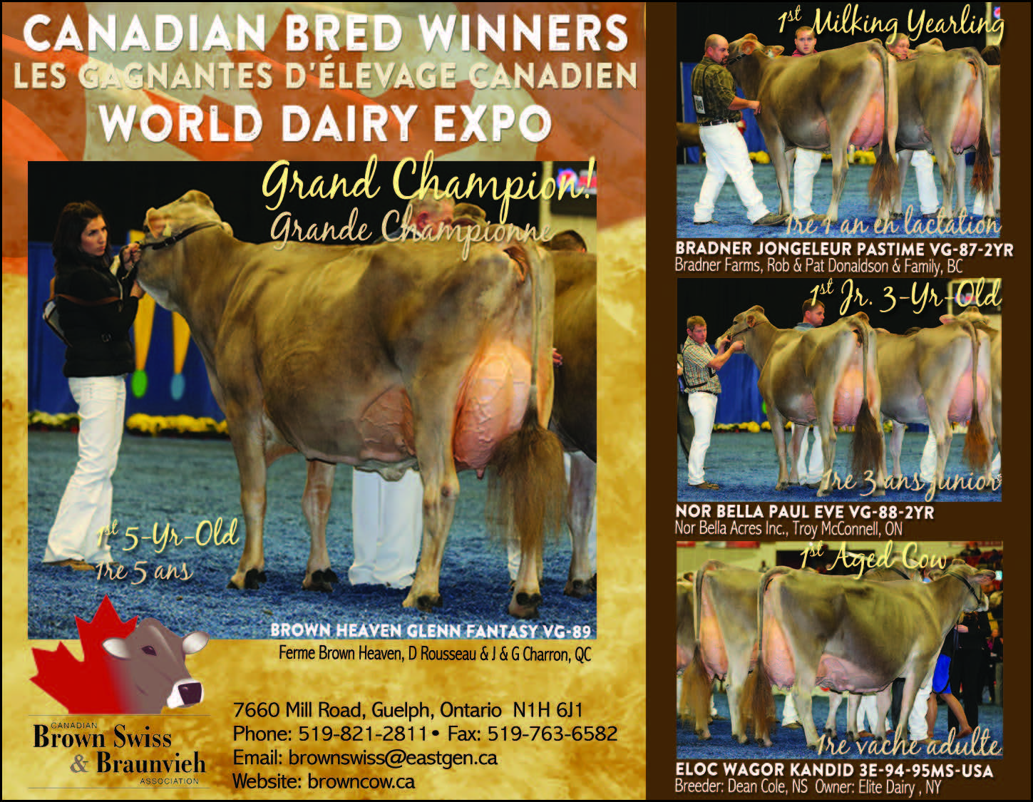

The membership is optimistic with high components, longevity and solid feet & legs, Brown Swiss is the desired breed of the future. Brown Swiss…Components that Pay…Cows that Last!

- # -
For further information, please contact:
Jessie Weir, Secretary Manager
Canadian Brown Swiss and Braunvieh Association
519-821-2811 or Email: brownswiss@eastgen.ca

